EXPERIMENT6: Threat Modeling and Security Hardening of an IoE Smart Banking System

Aim:
To develop and simulate a secure IoE Smart Banking System using threat modeling techniques and security hardening methods for protecting ATM transactions and customer data.

Objectives:
The objectives of this experiment are to simulate secure user authentication, generate smart ATM transactions, identify different security threats such as ATM spoofing, brute-force attacks, data tampering, and DoS attacks, block suspicious transactions, analyze security events, and visualize transaction and threat information using Python.

Software Requirements:
- Google Colab
- Python 3
- Pandas
- NumPy
- Matplotlib
- hashlib

Theory:
An IoE Smart Banking System connects banking devices such as ATMs, users, networks, and cloud-based services. Since banking systems handle sensitive customer and transaction information, security is very important.
Threat modeling is the process of identifying possible security threats before they can cause damage. In this experiment, possible threats include:
- ATM Spoofing: An attacker attempts to imitate or replace a legitimate ATM.
- Brute Force Attack: Repeated attempts are made to guess authentication information.
- Data Tampering: Transaction information is modified without authorization.
- DoS Attack: A service is overloaded to prevent legitimate users from accessing it.
Security hardening techniques are used to reduce these risks. In the program, password hashing is used for authentication and suspicious transactions are marked as blocked, while safe transactions are marked as success.

System Workflow:
User Authentication
↓
Password Hashing
↓
IoE Smart ATM
↓
Transaction Generation
↓
Threat Detection
↓
Security Decision
↓
SUCCESS / BLOCKED
↓
Security Report and Graphical Analysis

Algorithm:
- Start the program.
- Define the banking username and password.
- Convert the password into a SHA-256 hash.
- Create a list of IoE-enabled ATM devices.
- Generate customer IDs and transaction amounts.
- Randomly generate security conditions.
- Classify each transaction as SAFE or a security threat.
- Mark SAFE transactions as SUCCESS.
- Mark detected threats as BLOCKED.
- Store the transaction information in a Pandas DataFrame.
- Calculate the number of safe transactions and different threats.
- Display the security report.
- Generate graphs for transaction amounts, transaction status, threat distribution, and customer transactions.
- Complete the security analysis.

Program:
# ======================================================
# Threat Modeling & Security Hardening
# IoE Smart Banking System
# Google Colab
# ======================================================

import random
import hashlib
import pandas as pd
import matplotlib.pyplot as plt

print("=" * 60)
print(" IoE SMART BANKING SECURITY SYSTEM")
print("=" * 60)

# ------------------------------------------------------
# User Authentication
# ------------------------------------------------------

username = "admin"
password = "Bank@123"

password_hash = hashlib.sha256(password.encode()).hexdigest()

print("\nLogin Successful")
print("Username :", username)
print("Password Hash :", password_hash[:20], "...")

# ------------------------------------------------------
# Smart ATM Transactions
# ------------------------------------------------------

atm_ids = ["ATM001", "ATM002", "ATM003", "ATM004", "ATM005"]

records = []

for atm in atm_ids:

customer = random.randint(1001, 1050)
amount = random.randint(500, 10000)

threat = random.choice([
"SAFE",
"ATM Spoofing",
"Brute Force",
"Data Tampering",
"DoS Attack"
])

if threat == "SAFE":
status = "SUCCESS"
else:
status = "BLOCKED"

records.append([
atm,
customer,
amount,
threat,
status
])

# ------------------------------------------------------
# Display Transactions
# ------------------------------------------------------

df = pd.DataFrame(
records,
columns=[
"ATM ID",
"Customer ID",
"Amount",
"Threat",
"Status"
]
)

print("\nATM Transaction Report\n")
print(df)

# ------------------------------------------------------
# Security Summary
# ------------------------------------------------------

safe = len(df[df["Threat"] == "SAFE"])
spoof = len(df[df["Threat"] == "ATM Spoofing"])
brute = len(df[df["Threat"] == "Brute Force"])
tamper = len(df[df["Threat"] == "Data Tampering"])
dos = len(df[df["Threat"] == "DoS Attack"])

print("\n========== SECURITY REPORT ==========")
print("Safe Transactions :", safe)
print("ATM Spoofing :", spoof)
print("Brute Force :", brute)
print("Data Tampering :", tamper)
print("DoS Attack :", dos)

# ------------------------------------------------------
# Graph 1 - Transaction Amount
# ------------------------------------------------------

plt.figure(figsize=(8, 4))

plt.bar(df["ATM ID"], df["Amount"])

plt.title("ATM Transaction Amount")
plt.xlabel("ATM")
plt.ylabel("Transaction Amount")
plt.grid(axis="y")

plt.show()

# ------------------------------------------------------
# Graph 2 - Success vs Blocked
# ------------------------------------------------------

success = len(df[df["Status"] == "SUCCESS"])
blocked = len(df[df["Status"] == "BLOCKED"])

plt.figure(figsize=(5, 4))

plt.bar(
["SUCCESS", "BLOCKED"],
[success, blocked]
)

plt.title("Transaction Status")
plt.xlabel("Status")
plt.ylabel("Number of Transactions")

plt.show()

# ------------------------------------------------------
# Graph 3 - Threat Distribution
# ------------------------------------------------------

plt.figure(figsize=(6, 6))

plt.pie(
[safe, spoof, brute, tamper, dos],
labels=[
"SAFE",
"ATM Spoofing",
"Brute Force",
"Tampering",
"DoS"
],
autopct="%1.1f%%",
startangle=90
)

plt.title("Threat Distribution")

plt.show()

# ------------------------------------------------------
# Graph 4 - Customer Transaction Amount
# ------------------------------------------------------

plt.figure(figsize=(8, 4))

plt.plot(
df["Customer ID"],
df["Amount"],
marker="o"
)

plt.title("Customer Transaction Amount")
plt.xlabel("Customer ID")
plt.ylabel("Transaction Amount")
plt.grid(True)

plt.show()

# ------------------------------------------------------
# Final Message
# ------------------------------------------------------

print("\n======================================")
print("Threat Modeling Completed Successfully")
print("Security Hardening Applied")
print("System Protected Successfully")
print("======================================")
transaction amount for each ATM. It helps identify which ATM has generated higher or lower transaction values.

Output:
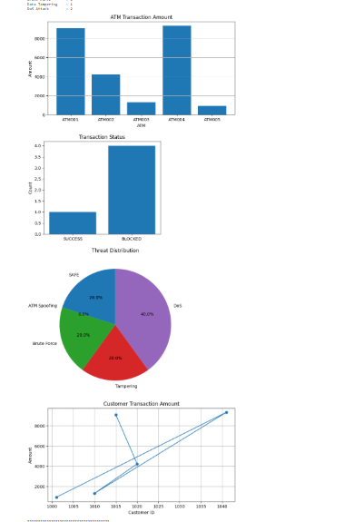

Result:
The IoE Smart Banking System was successfully simulated using Python in Google Colab. User authentication, ATM transactions, threat identification, transaction blocking, and security analysis were implemented. Different threats such as ATM spoofing, brute-force attacks, data tampering, and DoS attacks were identified and visualized using graphs. Thus, threat modeling and security hardening techniques were successfully demonstrated for an IoE-based smart banking system.

